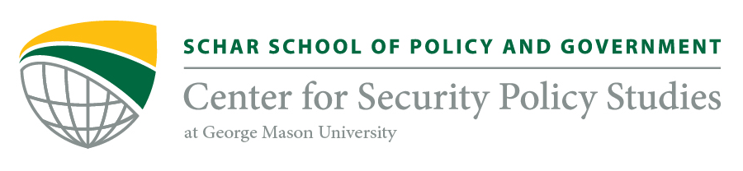

Spring & Fall 2019
CSPS-Korea Student Fellow Application

Please complete and submit this application along with your resume/CV and a relevant writing sample to cspskorea@gmail.com. Completed applications must be submitted no later than midnight on Friday, 21 December 2018.

Name: Click here to a text. |  |  | Email: Click here to enter text. |  | Phone: Click here to enter text.
Student Status: |  |  |  | Expected Graduation: Click here to enter text.
Major(s)/Focus Area(s): Click here to enter text.
Were you referred by a member of CSPS? If yes, who? Click here to enter text.
Expectations | All CSPS-Korea Student Fellows are expected to contribute to both the outreach and research missions of CSPS. All candidates are strongly encouraged to review the CSPS website to understand the CSPS mission, activities, and research areas. Please acknowledge your understanding of the Student Fellow requirement by checking the boxes below.
I am interested in pursuing, or continuing, a career in the fields of defense, intelligence, or security.
I understand that I will be expected to write ~3 short articles a semester and perform independent research.
I understand that I will be expected to attend the majority of CSPS-Korea meetings and events
I am able to commit to at least 1 year of service at approximately 2-5 hours per week (on average)
Relevant Coursework and Publications |  | Please describe all relevant coursework or publications. Indicate with a (*) if this coursework was not at GMU.  Click here to enter text.
Personal Statement  In 500 words or less, describe your academic and/ or professional goals and how a CSPS fellowship would further those goals |  | Click here to enter text.
Please provide any other information CSPS-Korea should have. |  | Click here to enter text.

